1. **To delete index**:
   1. 
2. To create index:
   1. 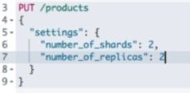
   2. This is PUT method to add a new document  
      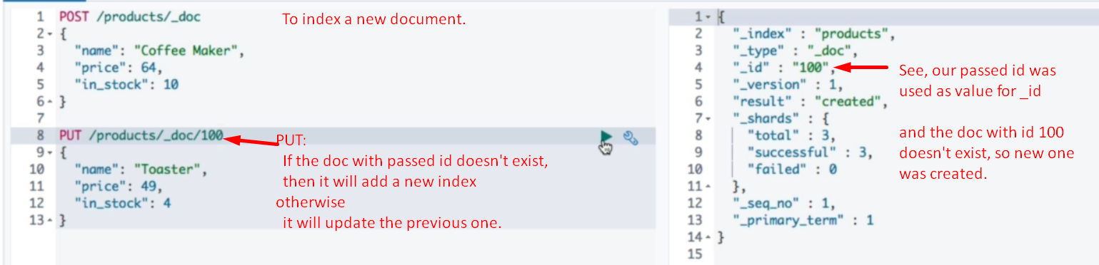

Getting, Retrieving Doc.

1. 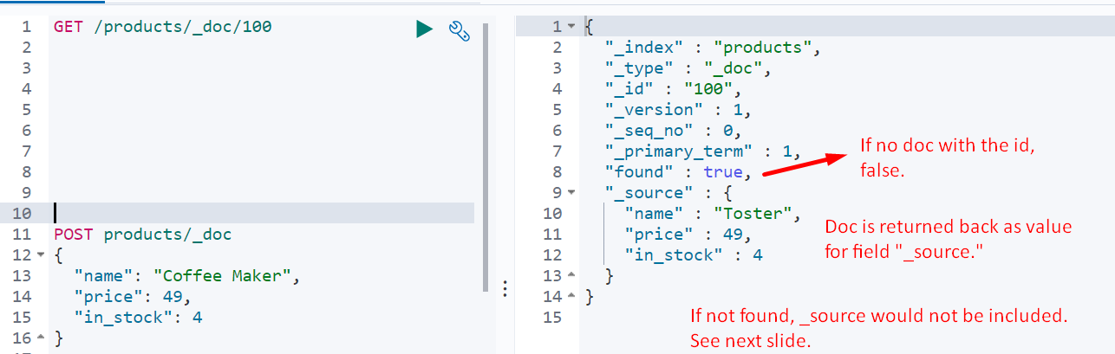

Updating Document

1. Updating doc.  
   **NOTE**: While updating we’re using POST not put but **_update** inside the endpoint.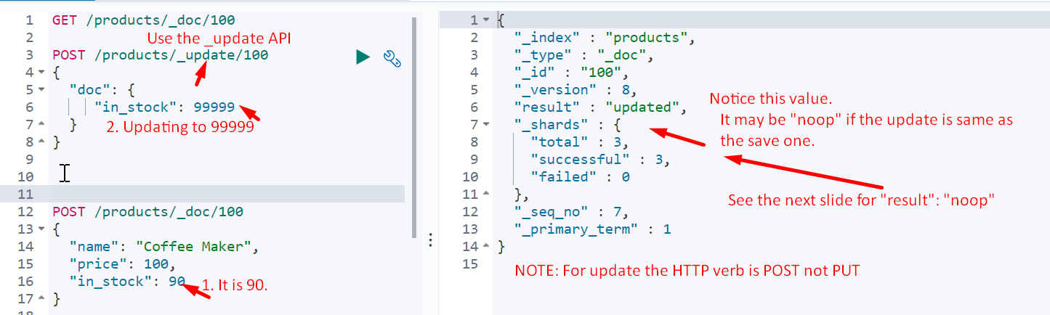
2. When updating to same values which are already set.   
   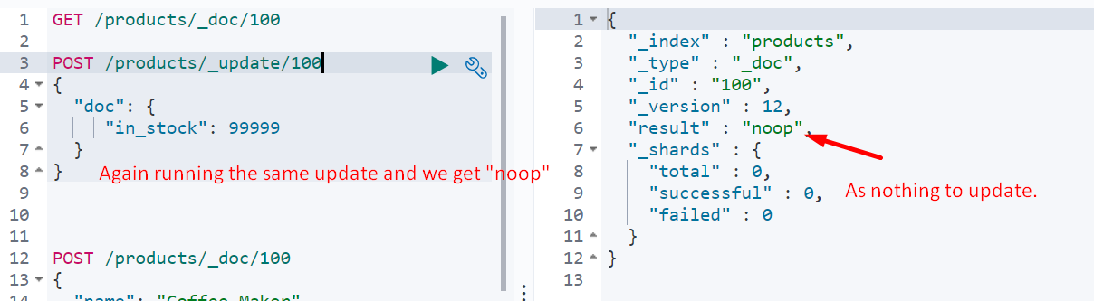
3. Updating doc to adding new fields (Dynamically Adding Property to Doc)  
   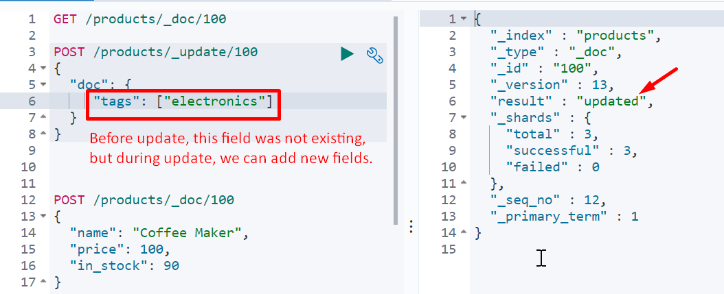

Script

1. **To update with script**: 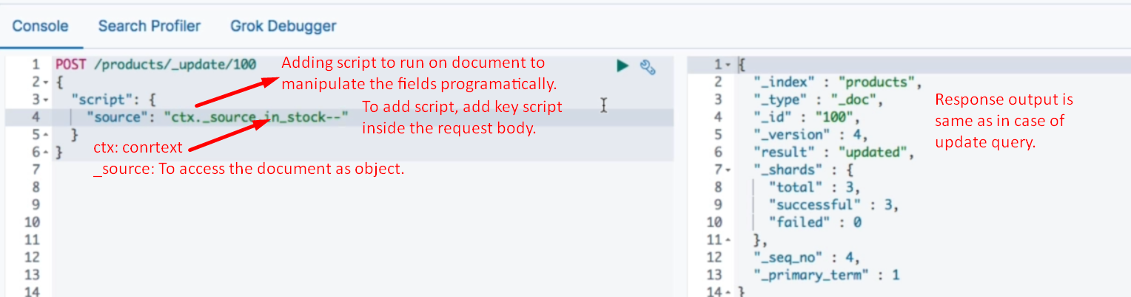  
   We can do other operations such as   
   Using -= operator 🡺 ctx._source.in_stock-=10; Using assignment 🡺 ctx._source.in_stock=10;
2. 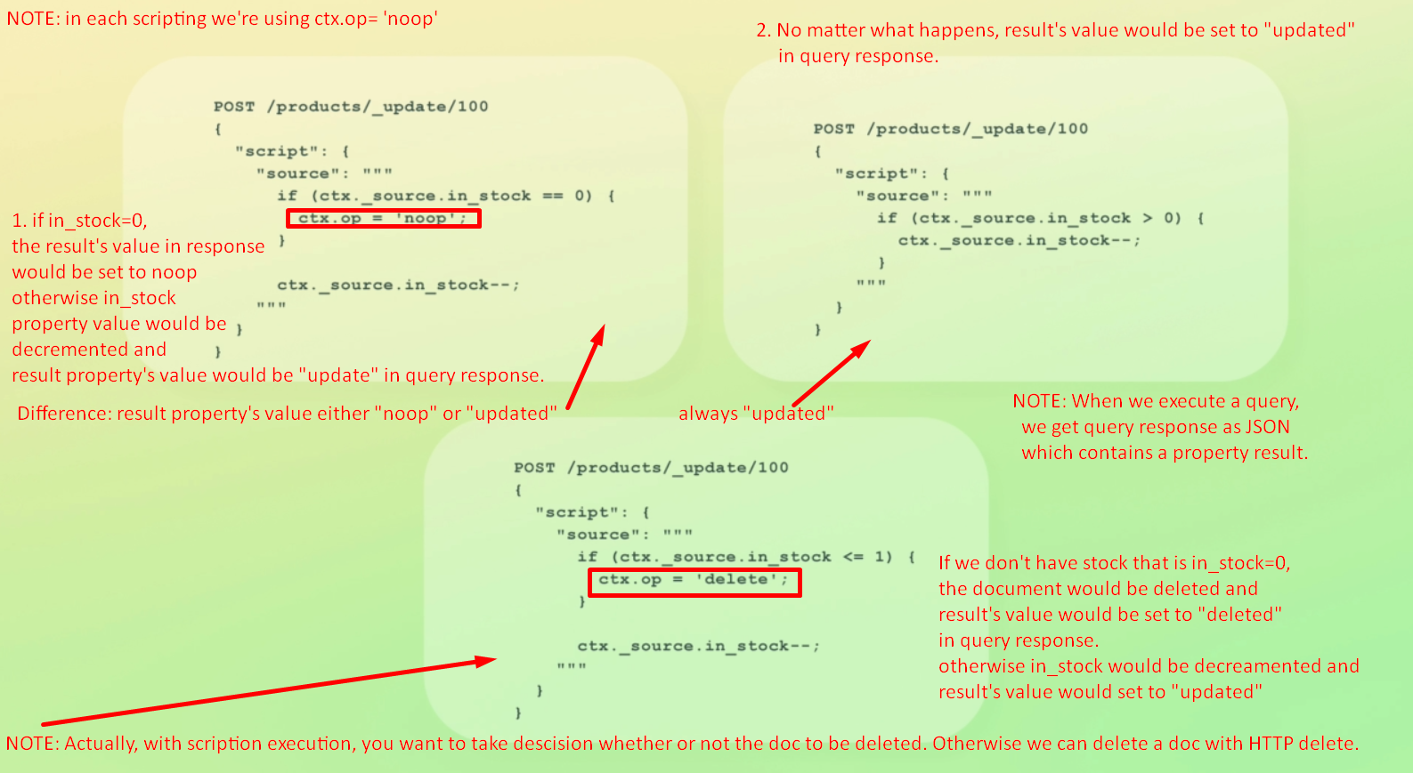
3. 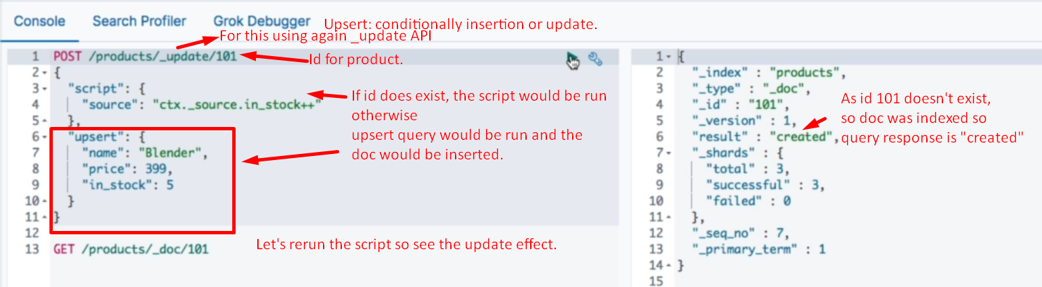

Upsert 🡺 To update or insert conditionally



Update query

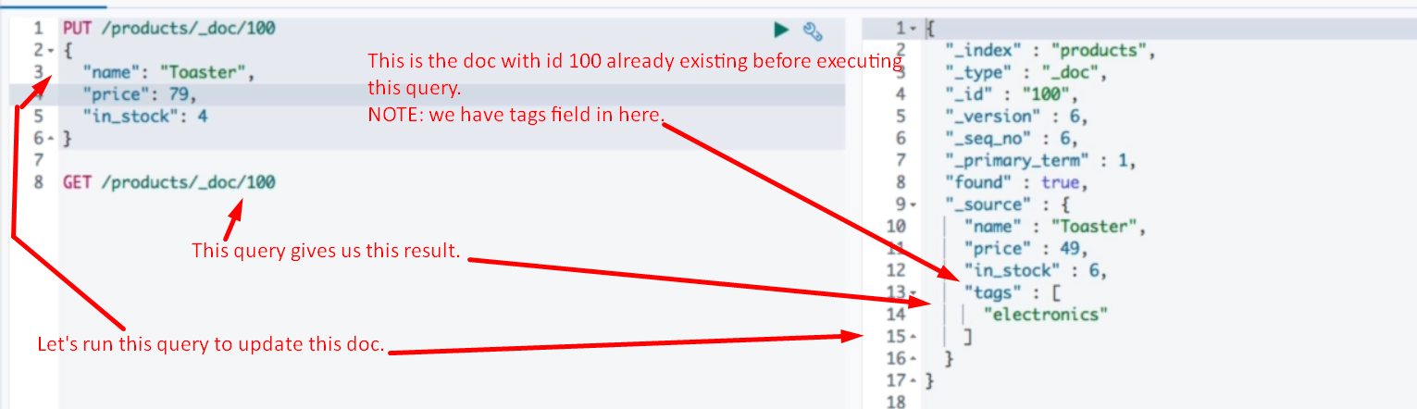

Delete document.

